Designing a C++-Based Cashiering System to Improve the Operational Efficiency of the General Management of Finances for NPMC Pet Food Store, Quezon City

Barizo, Julian Benedict DR
Guloya, Mc Aedrin
Katindig, Jiro Luis A.
Macasaet, John David C.
Medina, Jomz Ryle E.

Technological Institute of the Philippines
Quezon City

November 2025

Table of Contents

PROJECT TITLE 1
Table of Contents 2
Introduction 3
The Project 4
Hardware and Software Requirements 7
Statement of the Problem 8
Objectives 9
Flowchart of the System 10
Pseudocode 13
Data Dictionary 16
Program Code 18
Results and Discussion 31
Conclusion 32
References 33

Introduction

Founded in 2014, a small yet noble family-owned business opened its doors by a then married couple who both shared a love for animals. The idea of the small business actually came from the mother who had a shining compassion for pet animals that inspired not only herself but also her husband to start selling a set of quality pet food products across their local community. Throughout the years, the business had grown tremendously with the passion, commitment, and love poured into it by the family as well as the hired workers that came to be. With the growth of the business, their services expanded and extended further into printing services as well as customized products.

As of date, a nuance that can be considered that affects the current business model of NPMC Pet Food Store is their use of a fully manual system when processing sales or transactions. Additionally, these said transactions are rarely recorded or written down with the inventory tracking itself being merely done by simple observation instead of having a proper structured system in place. This means that it will be difficult to both keep track of sales data as well as what products are being sold. When this method worked during the early days of the business, it certainly is not sustainable now that the business has expanded in terms of the variety of products, services, as well as customers, making this manual method slow, inefficient, and prone to human errors.

The general problem faced by NPMC Pet Food Store as a business is their lack of an automated system that handles the management of sales as well as their inventory to replace their manual method. The specific challenges that the small business faces include the following:

- No Inventory System
- No Cashiering System
- Lack of Sales Reports
- Human Errors

To be able to address these challenges, a C++-based Cashiering and Inventory Management program is proposed for NPMC Pet Food Store. This new and digital system will be able to automate the process of transacting their sales, calculating total prices and change, as well as having a real-time inventory management, capable of outputting and keeping track of sales reports for a much easier way of keeping track of daily performance. By implementing the proposed system, the store can improve by various means such as in their efficiency, accuracy, as well as the quality of their service which can help the family continue on their mission of being able to not only serve pet lovers but also their furry companions alike.

The Project

The NPMC Pet Food Store C++-based Cashiering and Inventory Management System was designed under the “Agile” software development methodology due to the project’s timeframe being very limited. This methodology is known to emphasize flexibility while also keeping collaboration between members through iterative progresses. Additionally, the method was also chosen due to the need for continuous sets of improvement as well as refinement throughout the development of the program.

Through planning, prototyping, as well as implementation and testing, the timeframe for the project was divided into three sprints that each focus on a key stage of the development. Making use of the Agile methodology’s principles, we were able to directly pinpoint any problems as well as answer to feedback in order to make the necessary changes to be able to give functionally good results.
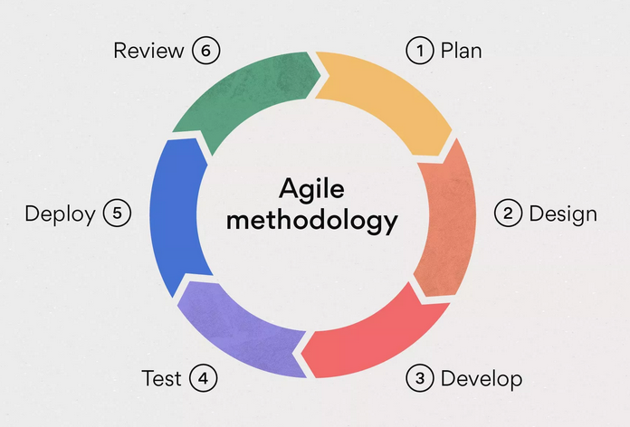
Figure 1: Agile Software Development Model.
Note. From What is Agile methodology? (A beginner’s guide) by S. Laoyan, 2025. Asana. https://asana.com/resources/agile-methodology

- Sprint 1: Planning and Design (Week 1)
  - In the first sprint, the focus was on finding out the background as well as identifying key problems that the business, NPMC Pet Food Store faced. Through questioning and observations, problems in their method of manual transaction as well as processing their inventory were found. In order to address these, an automated cashiering system capable of handling all of the management in sales, inventory tracking, as well as reporting was proposed.
  - During this week, the backbone of the pseudocode, flowchart, as well as the data dictionary were created and further developed until completion. All of these specifically outlined how the inputs from the user were to be processed, how the data were to be stored, and how all the alerts and reports were to be generated. To not further complicate the project, a terminal-based interface was selected for its accessibility and ease of use.

- Sprint 2: Development, Testing and Integration (Week 2)
  - In this second sprint, one of the most important components of the project took place, which was the coding of the system via C++. Taking note of the logical structure and approach of the pseudocode as well as flowcharts, the coding was done in a modular way which targeted product management, sales processing, as well as the generation of reports and alerts in separate tasks which were later on combined and connected into one singular program. These modules were also implemented using functions and switch-case statements instead to ensure both modularity as well as an easier readability.
  - File systems were added in order to have persistent storage of not only product names and details but also sales data. Throughout the sprint, after each feature was completed there was always a small-scale phase of testing to ensure proper application as well as prevent bugs to have greater reliability and user experience.

- Sprint 3: Refinement, Implementation, and Documentation (Week 3)
  - Finally, at the third and final sprint, the testing of the whole system for its accuracy and reliability was the most focused on aspect. Each of the functions including adding, editing, deleting products, sales processing, as well as generating reports were validated through multiple test cases. This was where a data-breaking bug was found where inputting a letter or invalid number in a situation where the user was supposed to enter a positive integer occurred. This was rectified immediately with the adding of two new verification functions that do the same thing but differentiate on their type of variable.
  - Other bugs were fixed and the overall logic was refined throughout the entire program, the interface smoothed out further. Once the program was running stable, it was compiled into an executable (.exe) which runs through the use of the terminal. The documentation as well as the instruction materials had been finalized in order to allow the business to smoothly transition from their manual method of transactions.

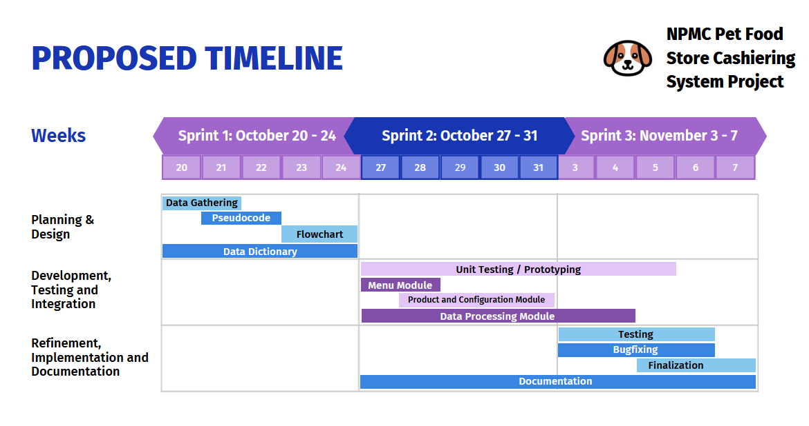
Figure 2: Proposed Timeline

The proposed timeline above presents the sequence of activities conducted throughout the development of the Cashiering System project. The schedule spans from October 20 up to November 7, divided into three weeks and phases which are: Planning and Design, Development, Testing and Integration, and lastly Refinement, Implementation and Documentation.

Hardware and Software Requirements

To be able to successfully run the C++-based NPMC Pet Food Store Cashiering and Inventory Management program, the following minimum hardware and software requirements are needed:

- OS: Cross-platform compatible with Windows, Linux, & macOS.
- CPU: Intel Core i3 processor (or equivalent/better)
- RAM: 4 GB (for stable performance)
- Storage: At least 100 MB (for storing both the program and data)
- Keyboard (for user input)
- Display Monitor (For viewing the terminal interface)

Statement of the Problem

NPMC Pet Food Store currently uses a fully manual method of processing transactions and little to no monitoring of their inventory. This manual process is slow and inefficient, prone to human errors especially as the business grows in the future. Without a proper system in place, it will get more and more difficult to be able to track sales performance, manage the levels of their stock, as well as have a consistent, reliable set of records. The proposed program will improve the operational efficiency of the general management of finances for the NPMC Pet Food Store.

The specific problems that were identified in the current system are as follows:

- No Inventory Tracking - The business has no easy and reliable way of automating the recording of product quantities or stock depletion which may either lead to overstocking or running out of stock.
- No Cashiering System - Transactions are processed manually which results in a slower service and the possibility of miscalculations in the total of sales as well as customer change.
- No Centralized Recordkeeping - There is no single location that the sales as well as inventory data is stored upon, making retrieving historical sales or being able to analyze trends difficult.
- No Sales Reports - The business is unable to generate daily or historical sales reports, making it harder to be able to monitor both profit and the performance overall.
- Human Errors - Manual entry and calculations may increase the likelihood of being able to make mistakes whether it be in the pricing, computing change, or recording of stock.

Objectives

The proposed program for NPMC Pet Food store aims to be able to automate the small business’ sales as well as inventory management to enhance not just in the recordkeeping of daily transactional data but also the efficiency, accuracy, as well as overall performance of the store. The general objective is to design and develop the C++-based cashiering and inventory system wherein it automates the sales processing, monitoring of stock, as well as the reporting of daily sales for the NPMC Pet Food store.

Specific Objectives:

- To create a C++ based program resembling that of a menu where users are able to navigate between adding, editing, and removing products from their inventory.
- To automate the computing of sales, change, as well as daily profit.
- To store and retrieve inventory as well as sales data on files for an easy way of keeping records.
- To both generate as well as archive sales reports daily and automatically.
- To Implement configurable stock alerts that alarm the user for when their products go below a certain threshold.
- To prevent any errors in entering data and fixing bugs that may arise.
- To ensure cross-platform compatibility so that the program is able to run across different operating systems.

Flowchart of the System

This part presents the flowchart developed for the Cashiering System. It visually represents the logical flow of the program, illustrating the sequence of processes, decisions, and data interactions that concur throughout the system’s operation. The flowchart serves as a guide to understanding how the system handles various user commands from managing products and processing sales to saving and generating reports ensuring that every operation follows a clear systematic path.

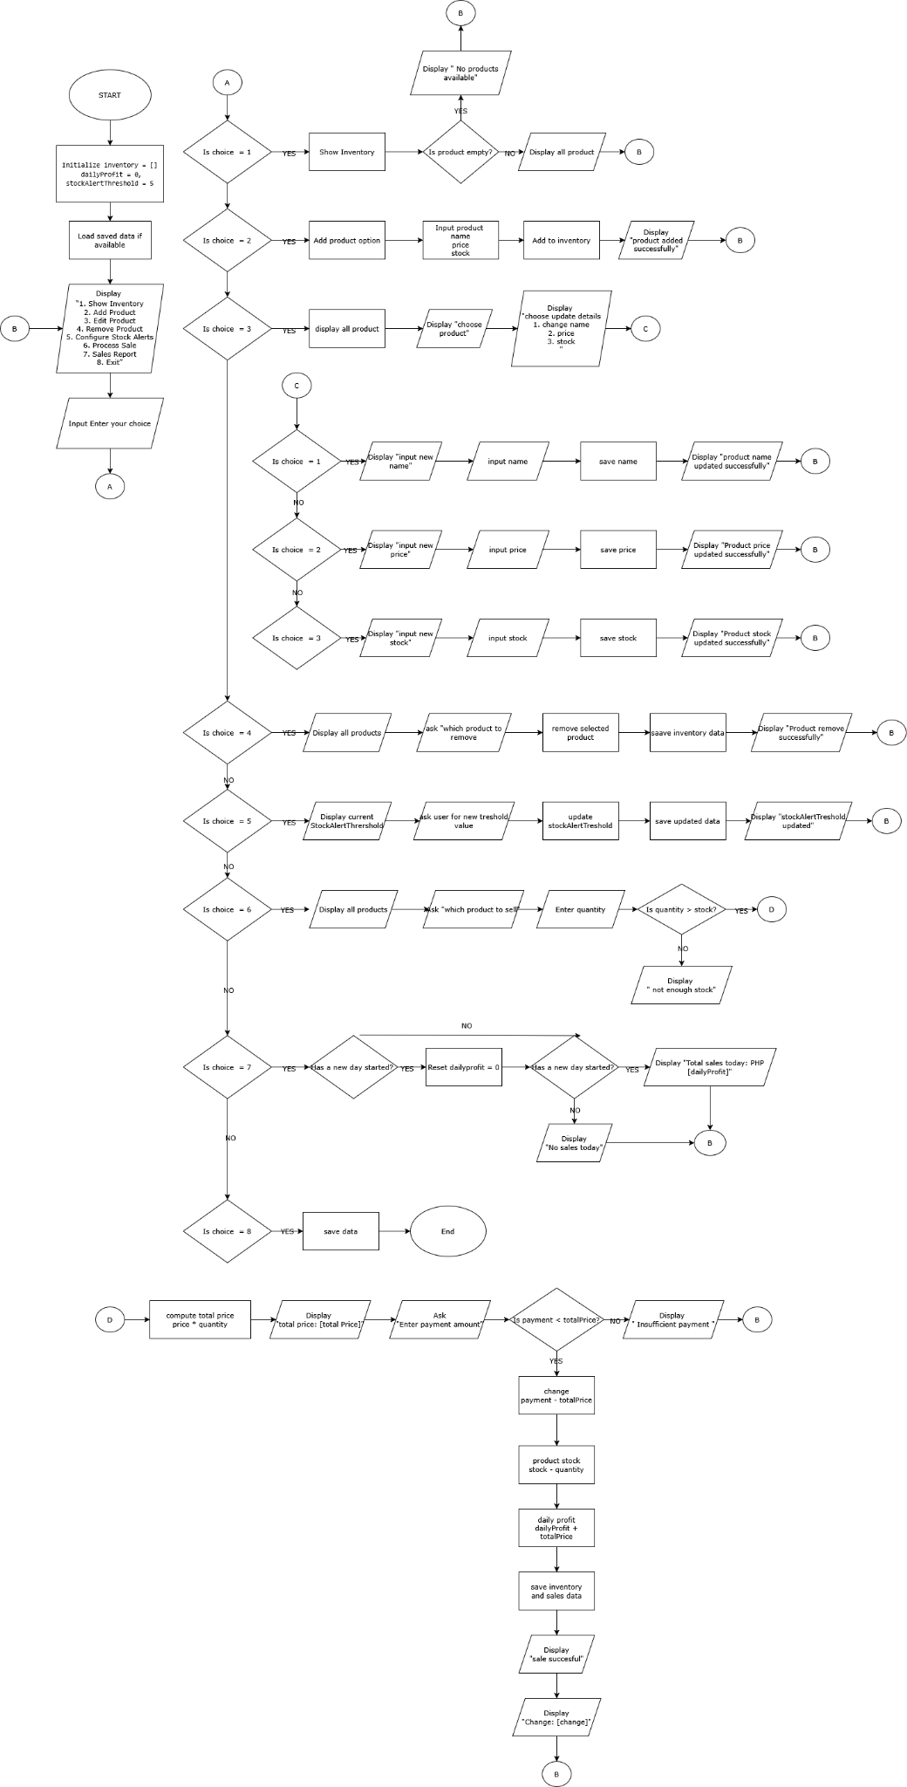

Figure 3: Flowchart of Cashiering System

Figure 1 presents the flowchart of the Cashiering System. The process beings with the initialization of data and loading of existing inventory and sales records.After this, the main menu is displayed, allowing the user to select among several options such as showing inventory, managing products, configuring stock alerts, processing sales transactions, generating sales reports, or exiting the program. Each user choice directs the system to perform a corresponding operation, after which it returns to the main menu until the user decides to exit. This structure ensures a smooth, continuous workflow and maintains the accuracy of sales and inventory data throughout the program’s execution.

Pseudocode

This presents the pseudocode developed for the Cashiering System. It serves as a logical foundation of the program, outlining the flow of operations and decision-making processes used to manage inventory and sales data. It showcases the step-by-step structure of the program. The pseudocode provides a clear overview of how the system handles user input, updates data, and how it maintains data flow throughout the entire process.

START

Initialize inventory as empty list
Initialize dailyProfit = 0
Initialize stockAlertThreshold = 5
Load saved data if available

REPEAT FOREVER
DISPLAY "1. Show Inventory"
DISPLAY "2. Add Product"
DISPLAY "3. Edit Product"
DISPLAY "4. Remove Product"
DISPLAY "5. Configure Stock Alerts"
DISPLAY "6. Process Sale"
DISPLAY "7. Sales Report"
DISPLAY "8. Exit"
GET userChoice

IF userChoice = 1 THEN
IF inventory is empty THEN
DISPLAY "No products available."
ELSE
FOR each product in inventory
DISPLAY product name, price, and stock
END FOR
END IF

ELSE IF userChoice = 2 THEN
ASK user for product name, price, and stock
CREATE new product with these details
ADD product to inventory
SAVE inventory data
DISPLAY "Product added successfully."

ELSE IF userChoice = 3 THEN
DISPLAY all products
ASK user which product to edit
ASK user whether to change name, price, or stock
UPDATE selected detail
SAVE inventory data
DISPLAY "Product updated successfully."

ELSE IF userChoice = 4 THEN
DISPLAY all products
ASK user which product to remove
REMOVE that product from inventory
SAVE inventory data
DISPLAY "Product removed successfully."

ELSE IF userChoice = 5 THEN
DISPLAY current stockAlertThreshold
ASK user for new threshold
UPDATE stockAlertThreshold
SAVE updated data
DISPLAY "Stock alert threshold updated."

ELSE IF userChoice = 6 THEN
DISPLAY all products
ASK user which product to sell
ASK user for quantity

IF selected product stock <= 0 THEN
DISPLAY "Product is out of stock."
ELSE IF quantity > selected product stock THEN
DISPLAY "Not enough stock."
ELSE
totalPrice ← product price × quantity
DISPLAY totalPrice
ASK user for payment amount

IF payment < totalPrice THEN
DISPLAY "Insufficient payment."
ELSE
change ← payment - totalPrice
product stock ← product stock - quantity
dailyProfit ← dailyProfit + totalPrice
SAVE inventory and sales data
DISPLAY "Sale successful."
DISPLAY "Change: ", change
END IF
END IF

ELSE IF userChoice = 7 THEN
IF new day has started THEN
RESET dailyProfit to 0
END IF

IF dailyProfit = 0 THEN
DISPLAY "No sales yet today."
ELSE
DISPLAY "Total sales today: PHP ", dailyProfit
END IF

ELSE IF userChoice = 8 THEN
SAVE all data
EXIT PROGRAM

ELSE
DISPLAY "Invalid choice. Try again."
END IF

FOR each product in inventory
IF product stock < stockAlertThreshold THEN
DISPLAY "Low stock alert for ", product name
END IF
END FOR
END REPEAT

END

Figure 4: Pseudo code of Cashiering System

Figure 2 presents the pseudocode of the Cashiering System, showing the overall process and flow of the program. It begins by initializing variables and loading existing data, followed by a continuous loop that displays the main menu. The system responds to inputs by the user by executing several different functions such as displaying the inventory, adding or editing products, processing sales, and generating reports. It also monitors the quantity of stock levels and provides alerts when items reach below the defined threshold.

Data Dictionary

The data dictionary is used to identify and organize all data elements used in the program. Our program is a cashiering system for a pet food store. The program is used to manage product inventory, process sales transactions, track daily profits, and maintain sales records.
The data dictionary contains the name of the data you are using. The data type and the size of the data is also identified. The fourth column is for describing the purpose of the data or how it’s used in the program.

Data Name | Size | Data Type | Description
- Product |  | struct | A structure that stores information about a product
- inventory | dynamic | vector <Product> | To manage the product inventory of the store, it contains the product structure
- name | Variable | string | For naming the product
- price | 8 bytes | double | For storing price information of a product
- stock | 4 bytes | int | Used for showing how much of the product is in stock
- dailyProfit | 8 bytes | double | The amount of total profit collected from sales
- totalPrice | 8 bytes | double | The total computed price for a sale
- moneyReceived | 8 bytes | double | The amount of money received for a purchase
- change | 8 bytes | double | Amount of change needed
- currentTime | 8 bytes | time_t | Current system time when generating sales report
- ltm | Variable pointer | tm* | Pointer to tm structure, used for local time conversion
- filename | 64 bytes (fixed char array) | char[] | File name created for daily sales archive
- stockAlertThreshold | 4 bytes | int | A threshold to activate low stock alerts
- clearconsole | 1 byte | bool | Used to control whether the console is cleared between actions
- salesDataFile | Variable | string | A file name used to keep sales data
- value | 8 bytes (double) or 4 bytes (int) | double/int | For numerical inputs that represent money

Table 1: Data Dictionary

Code

The NPMC Pet Food Store Cashiering and Inventory Management System is a C++ console-based application, coded to automate the small business’ daily transactions as well as inventory management. It provides a variety of features such as adding, editing, and removing products, the processing of sales, tracking of profits, and generating of daily reports. Additionally, the program also allows for configuring stock alerts which will notify the user when a specific product is running out while also storing all of these data for future access. The system makes use of several C++ Standard Template Library (STL) components such as vectors, file streams, and strings, to be able to efficiently manage both the product data and transactions. Moreover, it implements input validation that will make sure to reduce human error as well as a feature to allow cross-platform compatibility for Windows, Linux, and macOS through the implementation of an adaptive console clearing function.

#include <iostream> // Standard library
#include <fstream> // For exporting/importing or reading/writing the data
#include <string> // For naming the productcs, filenames, etc.
#include <vector> // For storing the data in vectors
#include <ctime> // For real time clock (to be implemented)
#include <iomanip> // For percision
#include <cstdlib> // For clearing the console
#include <limits> // For numeric limits, preventing bugs when letters are typed in price, etc.

using namespace std;

// Structure of the product having a name, its price, and the stock
struct Product {
string name;
double price;
int stock;
};

// Global variables
vector<Product> inventory; // Inventory variable
double dailyProfit = 0.0; // Daily profit from products sold within the day
time_t lastRunTime; // For keeping track of the day and when to reset daily profit
string salesDataFile = "salesdata.txt"; // For exporting the kept track of the day
int stockAlertThreshold = 5; // Default alert when stock goes below this (add configuration later)
bool clearconsole = true; // So that list appears when removing/editing a produjct

// Function Definition prototypes

//--Displaying Functions
void showInventory();
void displayMenu();

//--Adding, editing, removing prototypes
void addProduct();
void editProduct();
void removeProduct();

//--Sale processing
void processSale();

//--Alerts/reports
void configureStockAlerts();
void showStockAlerts();
void salesReport();

//--Data handling
void saveInventory();
void loadInventory();
void loadSalesData();
void saveSalesData();
void archiveSalesData();
double getValidatedDouble(const string &prompt);
int getValidatedInt(const string &prompt);

//--Console clearing
void clearConsole();

//--LOGIN SYSTEM------------------------------------------

// Opens up users.txt, reads it, and saves data into it
bool loadUsers(vector<pair<string, string>>& users) {
ifstream file("users.txt");
if (!file.is_open()) {
// If file doesn’t exist, create it with default user
ofstream createFile("users.txt");
createFile << "admin 12345\n";
createFile.close();
cout << "Created default users.txt file with login: admin / 12345\n\n";
file.open("users.txt");
if (!file.is_open()) return false;
}

string username, password;
while (file >> username >> password) {
users.push_back({username, password});
}
file.close();
return !users.empty();
}

// Handles the login for the user
bool login() {
vector<pair<string, string>> users;
if (!loadUsers(users)) {
cout << "Error: could not load user credentials.\n";
return false;
}

string username, password;
cout << "=== Login Required ===\n";
cout << "Username: ";
cin >> username;
cout << "Password: ";
cin >> password;

for (auto &u : users) {
if (u.first == username && u.second == password) {
cout << "\nLogin successful! Welcome, " << username << ".\n\nPress any key to continue...";
cin.ignore();
cin.get();
return true;
}
}

cout << "\nInvalid username or password. Access denied.\n";
return false;
}

//------------------------------------------------------------

// Main fujnction code
int main() {

// LOGIN FIRST!!
int loginAttempts = 0;
const int maxAttempts = 3;

while (loginAttempts < maxAttempts) {
if (login()) {
break;
} else {
loginAttempts++;
if (loginAttempts < maxAttempts) {
cout << "Try again (" << (maxAttempts - loginAttempts)
<< " attempt(s) remaining)\n\n\n";
} else {
cout << "\nToo many failed attempts. Exiting program.\n";
return 0;
}
}
}
clearConsole();

// Loads the following functions to start
loadInventory();
loadSalesData();

while (true) {
displayMenu();
int choice;
cout << "Enter your choice: ";
cin >> choice;

clearConsole(); // To clear the console after the user's choice

switch (choice) {
case 1: showInventory(); break;
case 2: addProduct(); break;
case 3: editProduct(); break;
case 4: removeProduct(); break;
case 5: configureStockAlerts(); break;
case 6: processSale(); break;
case 7: salesReport(); break;
case 8: saveSalesData(); exit(0); break;
default: cout << "Invalid choice. Try again.\n"; break; // If the choice isn't from 1-8
}
}

return 0;
}

// From here on out are the function definitions

//--DISPLAY INVENTORY/MENU--------------------------------------

// Shows the inventory
void showInventory() {
if (inventory.empty()) {
cout << "Inventory is empty.\n";
} else {
cout << "Inventory:\n";
for (size_t i = 0; i < inventory.size(); i++) {
cout << i + 1 << ". " << inventory[i].name
<< " | Price: " << inventory[i].price << " PHP"
<< " | Stock: " << inventory[i].stock << endl;
}
}
cout << endl;
cout << "Press any key to return/continue...\n";
cin.ignore();
cin.get();

if(clearconsole) {
clearConsole();
}
}

// Displaying menu function
void displayMenu() {
cout << " == NPMC Pet Food Store - Cashier Program ==\n\n";
cout << "Menu:\n";
cout << "1. Show Inventory\n";
cout << "2. Add Product\n";
cout << "3. Edit Product\n";
cout << "4. Remove Product\n";
cout << "5. Configure Stock Alerts\n";
cout << "6. Process Sale\n";
cout << "7. Sales Report\n";
cout << "8. Exit\n\n";
showStockAlerts();
cout << "\n\n";
}

//--ADD/EDIT/REMOVE---------------------------------------------

// Product adding function
void addProduct() {
Product p;
cout << "Enter product name: ";
cin.ignore(); // To ignore the newline left in buffer by previous cin
getline(cin, p.name); // Use getline to allow spaces
p.price = getValidatedDouble("Enter product price (PHP): ");
p.stock = getValidatedInt("Enter product stock: ");
inventory.push_back(p);
saveInventory();
saveSalesData(); // To save immediately in case the user exits by closing the window and prevent data loss
cout << "\nProduct added successfully.\n\n";
showInventory();
}

// Product editing function
void editProduct() {
clearconsole = false;
showInventory();
int productNum = getValidatedInt("Enter product number to sell: ");

if (productNum < 1 || productNum > inventory.size()) {
cout << "Invalid product number.\n";
return;
}

Product& p = inventory[productNum - 1];
cout << "Edit options:\n1) Name\n2) Price\n3) Stock\n";
int choice = getValidatedInt("Enter your choice: ");

switch (choice) {
case 1:
cout << "\nEnter new product name: ";
getline(cin, p.name); // For spaces in the product name
break;
case 2:
p.price = getValidatedDouble("Enter new product price (PHP): ");
break;
case 3:
p.stock = getValidatedInt("Enter new product stock: ");
break;
default:
cout << "\nInvalid choice!\n\n";
return;
}
saveInventory();
saveSalesData(); // To save immediately in case the user exits by closing the window and prevent data loss
cout << "\nProduct updated successfully!\n\n";
clearconsole = true;
showInventory();
}

// Product removing function
void removeProduct() {
clearconsole = false;
showInventory();
int productNum = getValidatedInt("Enter product number to remove: ");

if (productNum < 1 || productNum > inventory.size()) {
cout << "Invalid product number.\n";
return;
}

inventory.erase(inventory.begin() + productNum - 1);
saveInventory();
saveSalesData(); // To save immediately in case the user exits by closing the window and prevent data loss
cout << "Product removed successfully.\n\n";
clearconsole = true;
showInventory();
}

//--Sale processing function------------------------------------
void processSale() {
clearconsole = false;
showInventory();

int productNum = getValidatedInt("Enter product number to sell: ");

if (productNum < 1 || productNum > inventory.size()) {
cout << "Invalid product number.\n";
return;
}

Product& p = inventory[productNum - 1];

if (p.stock <= 0) {
cout << "Sorry, " << p.name << " is out of stock!\n";
return;
}

int quantity = getValidatedInt("Enter quantity to sell: ");

if (quantity <= 0) {
cout << "The quantity must be atleast 1!\n";
return;
}

if (quantity > p.stock) {
cout << "Not enough stock! There's only " << p.stock << " left.\n";
return;
}

double totalPrice = p.price * quantity;
cout << fixed << setprecision(2);
cout << "\nTotal price (PHP): " << totalPrice << endl;

double moneyReceived = getValidatedDouble("Enter money received (PHP): ");

if (moneyReceived < totalPrice) {
cout << "Insufficient amount. Sale not processed.\n";
return;
}

double change = moneyReceived - totalPrice;
dailyProfit += totalPrice;
p.stock -= quantity;

saveInventory();
saveSalesData(); // Save immediately to not lose any data

cout << "\nSale processed successfully!\n";
cout << "Change to give (PHP): " << change << endl;
cout << "Remaining stock for " << p.name << ": " << p.stock << "\n\n";

clearconsole = true;
showInventory();
}

//--ALERTS/REPORTS----------------------------------------------

// Stock Alert configuration setting function
void configureStockAlerts() {
cout << "Current stock alert threshold: " << stockAlertThreshold << endl;
cout << "Enter new stock alert threshold: ";
cin >> stockAlertThreshold;
cout << "Stock alert threshold set to: " << stockAlertThreshold << "\n\n";
saveSalesData(); // Saving the setting immediately
}

// To always show the stock alerts if there are any
void showStockAlerts() {
for (const auto& product : inventory) {
if (product.stock < stockAlertThreshold) {
cout << "Stock alert for " << product.name << ": Only "
<< product.stock << " left in stock.\n";
}
}
}

// Reporting the sales function
void salesReport() {
time_t currentTime = time(0);
tm *ltm = localtime(&currentTime);

if (difftime(currentTime, lastRunTime) > 86400) { // 86400 is the seconds in a day
dailyProfit = 0.0;
lastRunTime = currentTime;
cout << "Sales report reset. New day started.\n";
}

if (dailyProfit == 0.0) {
cout << "No sales yet!\n";
} else {
cout << fixed << setprecision(2);
cout << "Total sales for today: PHP " << dailyProfit << endl;
}
cout << "Press any key to return to menu...\n";
cin.ignore();
cin.get();
clearConsole(); // Console clearing
}

//--DATA HANDLING FUNCTIONS------------------------------------

// Saving product data to the file
void saveInventory() {
ofstream file("inventory.txt");
if (file.is_open()) {
for (const auto& product : inventory) {
file << product.name << endl; // In order to save names with spaces
file << product.price << " " << product.stock << endl;
}
file.close();
}
}

// Loading data from files
void loadInventory() {
ifstream file("inventory.txt");
if (file.is_open()) {
Product p;
while (getline(file, p.name)) { // In order to read names with spaces, preventing errors
file >> p.price >> p.stock;
file.ignore(); // Ignore the newline after reading price and stock
inventory.push_back(p);
}
file.close();
}
}

// Load the sales data
void loadSalesData() {
ifstream file(salesDataFile);
if (file.is_open()) {
file >> dailyProfit >> lastRunTime >> stockAlertThreshold;
file.close();
} else {
// Defaults if the file doesn't exist
dailyProfit = 0.0;
lastRunTime = time(0);
stockAlertThreshold = 5;
}

// Check if a new day started
time_t currentTime = time(0);
tm *currentTM = localtime(&currentTime);
tm *lastTM = localtime(&lastRunTime);

if (currentTM->tm_yday != lastTM->tm_yday || currentTM->tm_year != lastTM->tm_year) {
archiveSalesData();
dailyProfit = 0.0;
lastRunTime = currentTime;
saveSalesData();
}
}

// Save the sales data
void saveSalesData() {
ofstream file(salesDataFile);
if (file.is_open()) {
file << dailyProfit << " " << lastRunTime << " " << stockAlertThreshold;
file.close();
}
}

// For having a log of what was sold in previous days
void archiveSalesData() {
time_t t = time(0);
tm *ltm = localtime(&t);
char filename[64];
strftime(filename, sizeof(filename), "sales_%Y-%m-%d.txt", ltm);

ofstream out(filename, ios::app);
if (out.is_open()) {
out << fixed << setprecision(2);
out << "Total Sales for " << put_time(ltm, "%Y-%m-%d") << ": PHP " << dailyProfit << "\n";
out.close();
}
}

// Makes sure that the user enters a valid double number and not strings, symbols, etc. (For money)
double getValidatedDouble(const string &prompt) {
double value;
while (true) {
cout << prompt;
cin >> value;

if (cin.fail()) {
cin.clear(); // Clear error flags
cin.ignore(numeric_limits<streamsize>::max(), '\n'); // Discard junk input
cout << "\nInvalid input! Please enter a number.\n\n";
} else if (value < 0) {
cout << "\nValue cannot be negative. Try again.\n\n";
} else {
cin.ignore(numeric_limits<streamsize>::max(), '\n');
return value;
}
}
}

// Makes sure that the user enters a valid whole number (int) and not strings, symbols, etc. (For stock)
int getValidatedInt(const string &prompt) {
int value;
while (true) {
cout << prompt;
cin >> value;

if (cin.fail()) {
cin.clear();
cin.ignore(numeric_limits<streamsize>::max(), '\n');
cout << "\nInvalid input! Please enter a whole number.\n\n";
} else if (value < 0) {
cout << "\nValue cannot be negative. Try again.\n\n";
} else {
cin.ignore(numeric_limits<streamsize>::max(), '\n');
return value;
}
}
}

//--CONSOLE CLEARING------------------------------------------
// To be able to clear console between platforms in the case of different OS
void clearConsole() {
#ifdef _WIN32
system("cls"); // Windows
#else
system("clear"); // Linux or Mac
#endif
}

Figure 5. NPMC Pet Food Store Cashiering and Inventory Management Program

Contrary to the pseudocode and the flowchart that primarily use if-else statements to represent the processes of making decisions in the program, the actual code that is written via C++ instead makes use of switch cases as well as functions to refine these concepts. It still follows the same logical principles of the original design with minor improvements and bugfixing failsafes added, optimizing the code not only for clarity but also for modularity and actual practical use. A login system has also been implemented in the case of tampering by unwanted parties. To be able to use the program, the user is prompted with a menu that can be used to navigate through the different options and available functions of the program. The following are the summaries of its main functions as well as its processes for understanding and documentation:

- Inventory Management
  - To store the data, we made use of vectors where we put in the product details such as the name, price, and stock quantity. It allows the users to be able to add, edit, or remove products while automatically saving these changes to a text file, “inventory.txt” for future sessions.
- Sales Processing
  - The function we use for handling the main processing of sales, “processSale()” computes the total price, goes through a validation function as a failsafe, and then finally calculates the change to be returned where the total profit is tracked and archived automatically at the start of a new day.
- Data Storage and Retrieval
  - The program is able to store both the sales and inventory data via text files through file systems, making it lightweight as well as easy to access by the user themselves. Whenever the program is launched, it automatically reads the existing data through the functions, “loadInventory()” and “loadSalesData()”.
- Stock Alerts and Reports
  - The program includes a stock alert system with a configurable threshold that will constantly warn the user at the menu when the quantity of a specific product is running low. Additionally, a sales report feature allows the user to view the total profits amassed in a day or even access archived records from previous dates via the folder where the program is stored itself.
- Cross-Platform Compatibility
  - The program adapts when run under a different OS than Windows, its intended original operating system. The function, “clearConsole()” changes when using “system("cls")” in Windows and “system("clear")” for macOS or Linux.
- Error Handling and Validation
  - During bugfixing, an error was encountered where the data would completely corrupt if a string or character was inputted by the user when an integer was needed such as when choosing an option from the menu. This was later solved by adding input validation functions, “getValidatedInt()” and “getValidatedDouble()” to prevent errors when invalid entries happened such as using letters or negative numbers when prompted to enter an integer in choosing an option.

Results and Discussion

This section presents the results gathered from the implementation and testing of the Cashiering System. This project was conducted to improve efficiency regarding basic store operations such as product listing, inventory updates, and sales tracking. The outcomes were observed based on the functions executed within the code and how they respond to various inputs.

During testing, the system displayed the stored inventory data including the product names, prices, and the quantity. The add, edit, and remove functions updated the records according to the inputs provided. When a sale transaction was processed, the program calculated the total cost and change, then adjusted the stock level of the sold product.

The stock alert feature appeared when product quantities were below the specified threshold, indicating the need for restocking of the product. The program stored updated data upon exit, allowing it to be retrieved when reopened. The interface allowed the user to navigate through different options they desire and perform various functions without the need of complex commands.

Conclusion

The Cashiering System provided a logical approach to managing product inventory, recording sales, and monitoring profits. Based on the results and discussions, the system demonstrated that the program can perform basic cashiering tasks such as adding, editing, and removing products, processing transactions, and generating reports. Through the program's structure, and business processes that were previously done manually, it is now converted into a structured digital form that minimizes human error and improves operational proficiency.

Recommendations:
- Implementing a visual user interface would make the system easier to use. This would allow user interaction using buttons rather than command inputs
- Implementing a backup recovery feature would help preserve inventory and sales data in case of an unexpected situation like shutdowns or file loss
- Adding a barcode functionality would make the item selection and processing of sales faster and more accurate, minimizing errors in the input.

References

Cplusplus.com. (n.d.). <ctime> (time.h). Retrieved from: https://cplusplus.com/reference/ctime/

Cplusplus.com. (n.d.). <iomanip>. Retrieved from: https://cplusplus.com/reference/iomanip/

GeeksforGeeks. (2025, October 28). File handling in C++. Retrieved from: https://www.geeksforgeeks.org/cpp/file-handling-c-classes/

Laoyan, S. (2025, February 20). What is Agile methodology? (A beginner’s guide). Asana. Retrieved from: https://asana.com/resources/agile-methodology

W3Schools. (n.d.). C++ Files Retrieved from: https://www.w3schools.com/cpp/cpp_files.asp

TutorialsPoint. (n.d.). <ctime> (time.h). Retrieved from: https://www.tutorialspoint.com/cpp_standard_library/vector.htm

Forrester, R. (2024, October 6). Understanding and Using cin.ignore() in C++. Retrieved from: https://medium.com/@ryan_forrester_/understanding-and-using-cin-ignore-in-c-09ead6df053f

